

In baptism, God frees us from sin and death and gives us new life into a living hope.

In baptism, we become part of the body of Christ, receive the gift of God’s Spirit, and   
are joined in God’s mission for the life of the world.

We live *baptism* by…

* Living in community

* Experiencing God’s grace through hearing the Word of God and sharing in the Lord’s Supper

* Proclaiming God’s love through our words and deeds,

* Serving all people, following Jesus’ example

* Striving for justice and peace in all the earth

Receive the + sign of the cross, a sign of God’s endless love and mercy for you.

**Helpful Ways Congregations Can**

**Honor Baptismal Vows Made to our College Students:**

* Remember that the **baptismal promises** made are for the sake of the other and the world, freeing congregations and students to act out of faith and not simply self-interest! This is such a counter-cultural and grace-filled message! They need to hear and experience this message long before college. How is your congregation tending to the faith formation of youth post-confirmation through their high school graduation?
* Utilize the **Christian rituals** we have (blessings, sacraments, shared meals, prayer, etc.) to mark the academic journey. Pray for and bless students during a regular worship service before they leave for college, (or every year!) and at their homecomings; honor their vocational milestones, not just their graduations; and intentionally ask them to share about their lives and faith when they are home—maybe over coffee, or speaking to a youth group, or speaking/preaching in worship if they'd like.
* **Get their emails and phone numbers** and send their names and this information to the Lutheran campus pastor/ministry staff at the university or college they’re attending. (The ELCA has a presence at over 180 universities and colleges, not to mention the MANY cooperating congregations that reach out to campus communities!) An easy way to refer is to go to: [**luminelca.org/refer-a-student**](https://luminelca.org/refer-a-student/)
* **Visit them on campus**. You could visit at the Lutheran Campus Ministry building, if there is one, and introduce them to the local campus pastor/ministry staff.
* Send them **cards, emails, or care packages** in the mail.
* **Let them know** that their home congregations continue to pray for and remember them.
* If your congregation is near a campus, **offer church space** for student use— students often need space for rehearsals, recitals, meetings, retreats, or study.
* After they graduate, intentionally **follow up with them** and help them connect to churches/faith communities beyond college.

**Helpful Ways Congregations Can Support   
Lutheran Campus Ministry:**

* **Pray** for Lutheran Campus Ministries.
* **Financially support** Lutheran   
  Campus Ministries.
* **Volunteer--** from cooking meals to sharing prayer shawls to serving on a campus ministry Board, or committee… Ask your local campus pastor/ministry staff how your time and skills could be used to support the ministry.
* **Consider having a “Campus Ministry Sunday”** at your congregation: raise awareness of the Church’s presence and mission to students, faculty, and staff at universities and colleges across the United States and receive a special offering for the campus ministry.
* Make youth and young adults **aware** of Lutheran Campus Ministry and make the connection between them and Lutheran Campus Ministry so that they can continue to grow in faith!
* Be an **advocate** for Lutheran Campus Ministry, locally and synodically. Tell stories of your campus ministries; you can reach out to campus ministers and boards for ideas. Remind your congregation that its ELCA Mission Support helps to sustain ministries like Lutheran Campus Ministry!

**Your SEMN Synod Lutheran Campus Ministries:**

**Lutheran Campus Center, Winona**

**Corrine Haulotte, Campus Pastor**  
451 Huff St- PO Box 4, Winona, MN 55987

Website: [www.lccwinona.com](http://www.lccwinona.com)  
Facebook: [facebook.com/LCCWinona](http://facebook.com/LCCWinona)

Instagram: /lccwinona  
Email: pastorcorrine@gmail.com  
Phone: 507-452-8316

**Crossroads Lutheran Campus Ministry, Mankato  
Jenna Couch, Campus Pastor**331 Dillon Ave, Mankato, MN 56001  
Website: [crossroadsatmnsu.org](https://crossroadsatmnsu.org/)  
Facebook: [facebook.com/MankatoCrossroads](http://facebook.com/MankatoCrossroads)  
Email: CrossroadsAdvocate @ gmail.com  
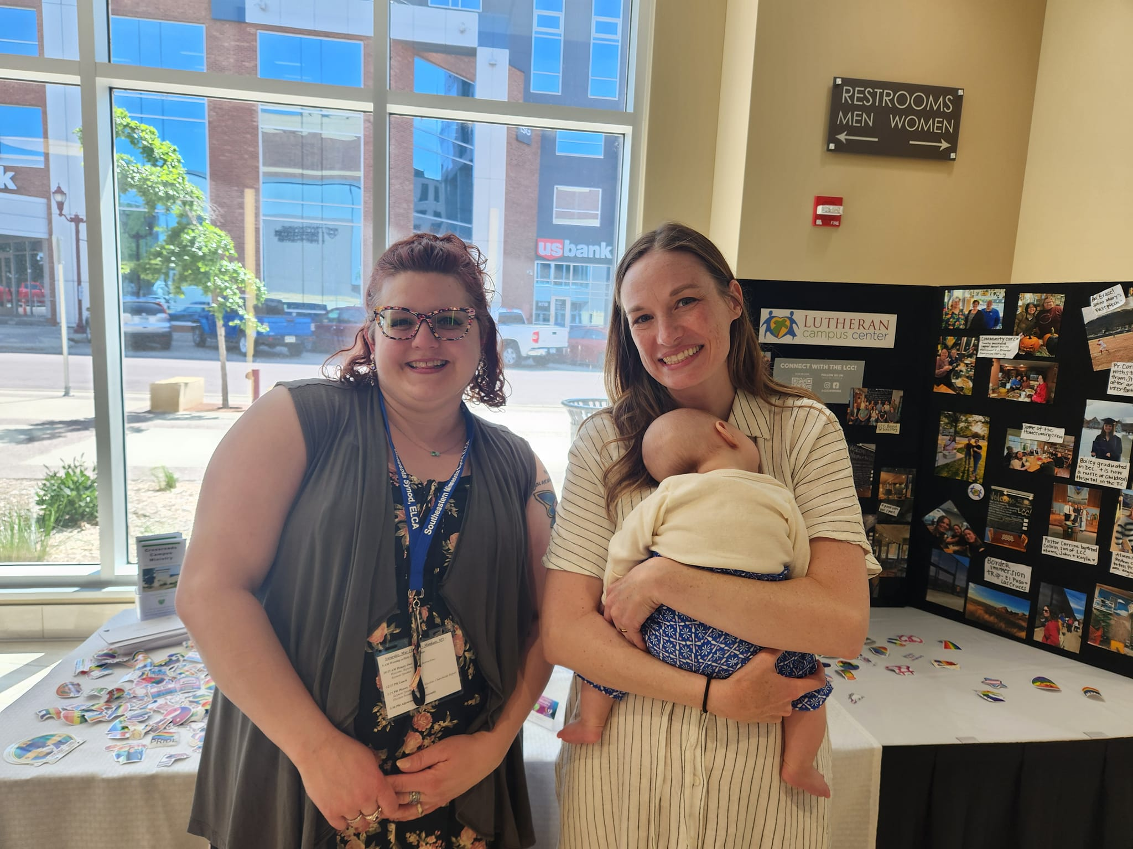Phone: 507-625-6779

*Pastor Jenna Couch & Pastor Corrine holding Baby Sadie at Synod Assembly 2024*