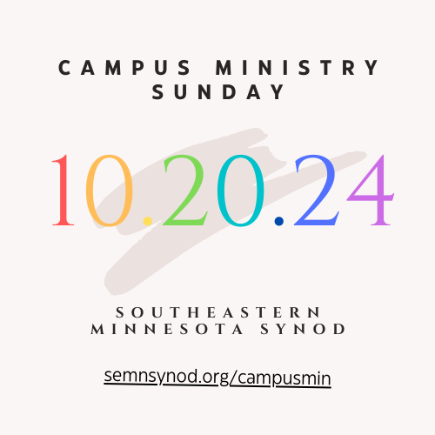**WORSHIP RESOURCES**

**PRAYER**

*Holy and Gracious God,*

*We give you thanks and praise for the many you have called and the ministries you bless. Today, we lift before you the campus ministries of the ELCA, particularly those within the Southeastern Minnesota Synod, Crossroads Lutheran Campus Ministry Mankato and the Lutheran Campus Center of Winona.*

*Pour your blessings on these ministries as they invite people in academic settings more deeply into Jesus Christ and the communities that bear his name, so that they may discover and fulfill their vocation as disciples and, through them, the world may be reminded that it is deeply loved.*

*Pour your blessings on those within the ministry who dare to open themselves to new opportunities to expand one*’*s mind, to deepen one*’*s faith and to inspire service, so all they do may be a proclamation of your compassion and peace.*

*Pour your blessing on those who accompany students, faculty, and staff through the joys and challenges of college life. May your gospel give witness to truth within this context of ministry where careful research, critical thinking, and personal development dynamically come together.*

*We pray in the name of Jesus. Amen.*

**SUGGESTED SCRIPTURE READINGS**

Old Testament:

*Genesis 12: 1-9

*Deuteronomy 6: 1-9

*Jeremiah 18: 1-6

New Testament:

*2 Timothy 1: 1-7, 14

*Philippians 1: 3-11

*Romans 12: 9-18

Gospels:

*Mark 1: 16-20

*Luke 13: 10-17

*John 1: 35-42 (or through 46)

*Luke 6: 27-36

**SUGGESTED HYMNS**

Gathering

ACS 1038 “God, We Gather As Your People”

ELW 641 “All Are Welcome”

ELW 526 “God Is Here!”

Hymn of the Day

ACS 1062 “Build a Longer Table”

ACS 1004 “Faith Begins By Letting Go”

ELW 583 “Take My Life, That I May Be”

ELW 768 “Lead Me, Guide Me”

Offering

ACS 978 “God Welcomes All”

ACS 1005 “Ask the Complicated Questions”

ELW 807 “Come, Thou Fount of Every Blessing”

ACS 1065 “Can You Feel the Seasons Turning”

Communion

ELW 770 “Give Me Jesus”

ELW 496 “One Bread, One Body”

ACS 987 “Guide My Feet”

ACS 925 “You Make Beautiful Things”

Sending

ELW 731 “Earth and All Stars”

ACS 991 “Go to the World”

ACS 1036 “Commonwealth Is God’s Commandment”

ELW 712 “Lord Whose Love in Humble Service”

ELW 763 “My Life Flows On in Endless Song”

**LITANY OF THANKSGIVING FOR CAMPUS MINISTRY**(adapted from Chris Heavner)

One: Source and Ground of all Goodness, we give you thanks for the life of our church on campuses, especially in Winona and Mankato.

One: God of knowledge and wisdom, you invite us to explore your world and to discover your secrets. For minds and hearts and hands with which to discover and learn, we offer our prayers to you.

**All: We thank you, O Lord.**

One: On this Campus Ministry Sunday, we offer our prayers for those in this community who are enrolled at institutions of higher education. We send them forth into the world with our love and the assurance of our continued prayers.

**All: We thank you, O Lord.**

One: May these students flourish in their studies, grow in self-confidence and be strengthened in their faith journey. We pray that they may become more fully the people you created them to be.

**All: We thank you, O Lord.**

One: We pray for those left behind, for families & friends, teachers & mentors. In gratitude for all they have given, we offer our prayers.

**All: We thank you, O Lord.**

One: Trusting in your mercy, and dependent on your grace, we offer our prayers to you who welcomes all and whose love never fails. **Amen.**