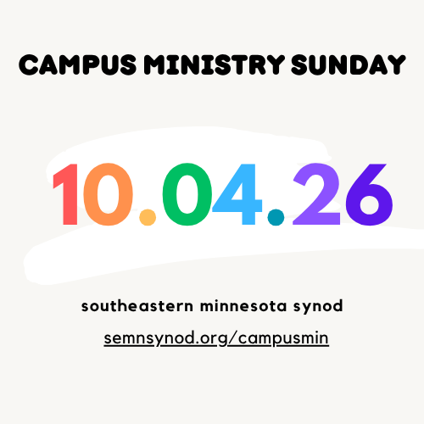
Campus Ministry Sunday: October 4, 2026
Southeastern Minnesota Synod

On this Sunday, you are encouraged to lift up the Lutheran Campus Ministries of the ELCA in general and the campus ministries in our synod, the Lutheran Campus Center of Winona and Crossroads Lutheran Campus Ministry in Mankato. With the news of Crossroads Campus Ministry’s Holy Closure in December, this is an appropriate time to name feelings around that— thanks for the many years of service, sadness at this huge loss, hope for the future God holds…
The LCC in Winona is happy to share resources with you about campus ministry, and we are always grateful for student referrals. Campus ministry welcomes your kind support on this day and throughout the year. And more importantly, it covets your prayers for this work and for the students who participate. Thank you!

WORSHIP RESOURCES

SUGGESTED SCRIPTURE READINGS
Old Testament:
*Genesis 12: 1-9
*Deuteronomy 6: 1-9
*Jeremiah 18: 1-6
New Testament:
*2 Timothy 1: 1-7, 14
*Philippians 1: 3-11
*Romans 12: 9-18
Gospels:
*Mark 1: 16-20
*Luke 13: 10-17
*John 1: 35-42 (or through 46)
*Luke 6: 27-36

SUGGESTED HYMNS
Gathering
ACS 1038 “God, We Gather As Your People”
ELW 641 “All Are Welcome”
ELW 526 “God Is Here!”

Hymn of the Day
ACS 1062 “Build a Longer Table”
ACS 1004 “Faith Begins By Letting Go”
ELW 583 “Take My Life, That I May Be”
ELW 768 “Lead Me, Guide Me”

Offering
ACS 978 “God Welcomes All”
ACS 1005 “Ask the Complicated Questions”
ELW 807 “Come, Thou Fount of Every Blessing”
ACS 1065 “Can You Feel the Seasons Turning”

Communion
ELW 770 “Give Me Jesus”
ELW 496 “One Bread, One Body”
ACS 987 “Guide My Feet”
ACS 925 “You Make Beautiful Things”

Sending
ELW 731 “Earth and All Stars”
ACS 991 “Go to the World”
ACS 1036 “Commonwealth Is God’s Commandment”
ELW 712 “Lord Whose Love in Humble Service”
ELW 763 “My Life Flows On in Endless Song”

PRAYER
God of All,
You are with us from the very beginning of our lives to the very end- and every space in between; we praise you for your steadfast presence in our lives. We give you thanks for the many you have called and the ministries you bless. Today, we lift before you the campus ministries of the ELCA, particularly within the Southeastern Minnesota Synod, the Lutheran Campus Center of Winona and Crossroads Lutheran Campus Ministry of Mankato.
Pour your blessings on campus ministries across the country as they invite people in academic settings more deeply into Jesus Christ and the communities that bear his name, so that they may discover and fulfill their vocation as disciples and, through them, the world may be reminded that it is deeply loved.
Pour your blessings on those within the ministry who dare to open themselves to new opportunities to expand one’s mind, to deepen one’s faith and to inspire service, so all they do may be a proclamation of your compassion and peace.
Pour your blessing on those who accompany students, faculty, and staff through the joys and challenges of college life. May your gospel give witness to truth within this context of ministry where careful research, critical thinking, and personal development dynamically come together.
Finally, we give you thanks, dear God, for the ministry of Crossroads and ask that you be with the Board as they prepare for its Holy Closure in December. Be with each of us as we receive this news. Help us to be kind to ourselves and one another through the many emotions that come with this transition.
We pray in the name of Jesus. Amen.

LITANY OF THANKSGIVING FOR CAMPUS MINISTRY
(adapted from Chris Heavner)
One: Source and Ground of all Goodness, we give you thanks for the life of our church on campuses.

One: God of knowledge and wisdom, you invite us to explore your world and to discover your secrets. For minds and hearts and hands with which to discover and learn, we offer our prayers to you.
All: We thank you, O Lord.

One: On this Campus Ministry Sunday, we offer our prayers for those in this community who are enrolled at institutions of higher education. We send them forth into the world with our love and the assurance of our continued prayers.
All: We thank you, O Lord.

One: May students flourish in their studies, grow in self-confidence and be strengthened in their faith journey. We pray that they may become more fully the people you created them to be.
All: We thank you, O Lord.

One: We pray for families & friends, teachers & mentors. In gratitude for all they have given, we offer our prayers.
All: We thank you, O Lord.

One: Trusting in your mercy, and dependent on your grace, we offer our prayers to you who welcomes all and whose love never fails. Amen.

